**// Subroutine : UpdateButtonClick_CONTRAST_CUFF_INNER()**

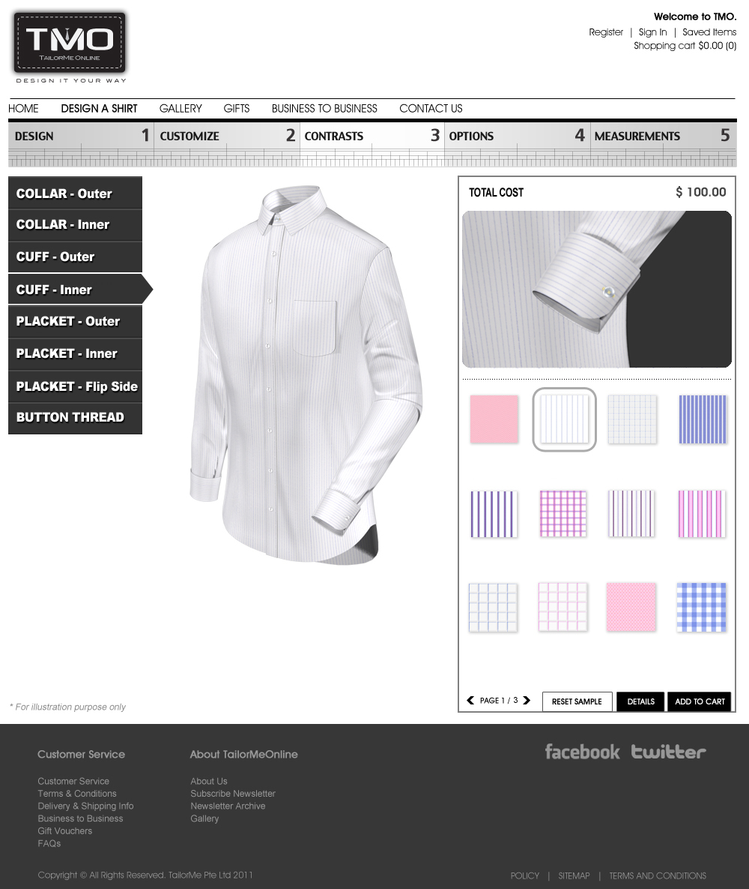

Upon clicking the any fabric button:

// Note : Number the fabric icon in running number from 0001 onwards (ie. 0001, 0002, … , 0031)

CuffLyr03[4] = ConvertToString(Icon Number);

ShirtLyr13[4] = ConvertToString(Icon Number);

Call Subroutine : RefreshFilenames();

Call Subroutine : DisplayCuff(); // This updates the cuff window

Call Subroutine : DisplayFullview(); // This updates the full shirt window

**// End of Subroutine : UpdateButtonClick_ CONTRAST_ CUFF_INNER()**